**Technical report for ANN experiments:**

* MNIST

Algorithm: Convolutional neural network, Sequential layer

Initial settings: activation = relu, softmax, optimizer=rmsprop

Parameter updates on epochs:

loss: 0.2750 - accuracy: 0.9202

Final parameter values after training:

loss: 0.0035 - accuracy: 0.9989

loss v/s epoch :

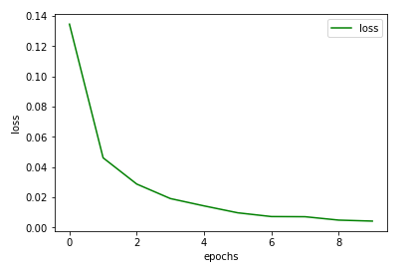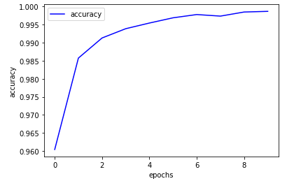

f1 score : 0.99

* Wisconsin Breast Cancer

lgorithm: Dense neural network, Sequential layer

Initial settings: activation = relu, sigmoid ,optimizer=adam,early stopping point=94

Loss = binary cross entropy

Parameter updates on epochs :

loss: 0.6640 - accuracy: 0.7115 - val_loss: 0.6297 - val_accuracy: 0.7902

Final parameter values after training:

loss: 0.0398 - accuracy: 0.9845 - val_loss: 0.1007 - val_accuracy: 0.9720

Train vs test loss:

Train vs test accuracy:

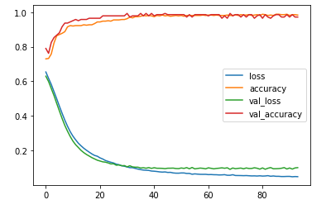

F1 score : 0.977

* IRIS

Algorithm: Dense neural network , Sequential

Initial settings: activation = relu, softmax,optimizer=rmsprop, epochs=30

Parameter updates on epochs :

loss: 0.9976 - accuracy: 0.5296 - val_loss: 0.7072 - val_accuracy: 0.5526

Final parameter values after training:

loss: 0.0850 - accuracy: 0.9762 - val_loss: 0.1027 - val_accuracy: 0.9474

Train vs test loss:

Train vs test accuracy:

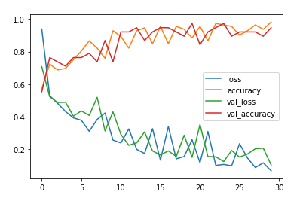

Accuracy score:94.73684210526315

* Bank-Note

Algorithm: Dense neural network , Sequential

Initial settings: activation = relu, sigmoid, optimizer=rmsprop,

Parameter updates on epochs :

loss: 0.6203 - accuracy: 0.6239 - val_loss: 1.0177 - val_accuracy: 0.5236

Final parameter values after training:

loss: 0.6132 - accuracy: 0.6384 - val_loss: 0.9985 - val_accuracy: 0.5491

Train vs test loss:

Train vs test accuracy:

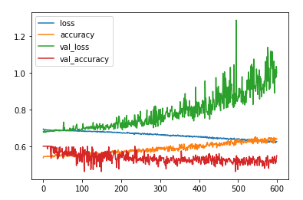

F1 score : 0.4150943396226415